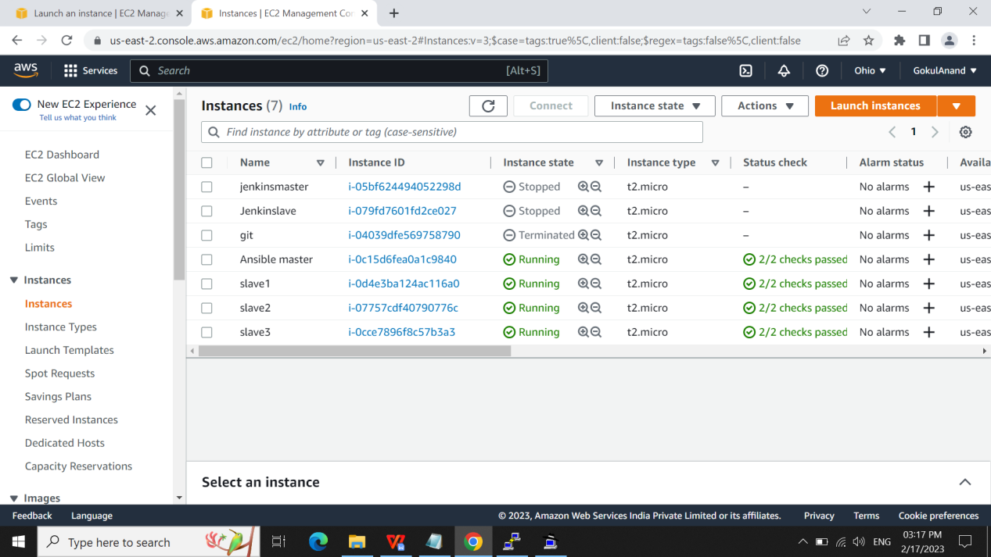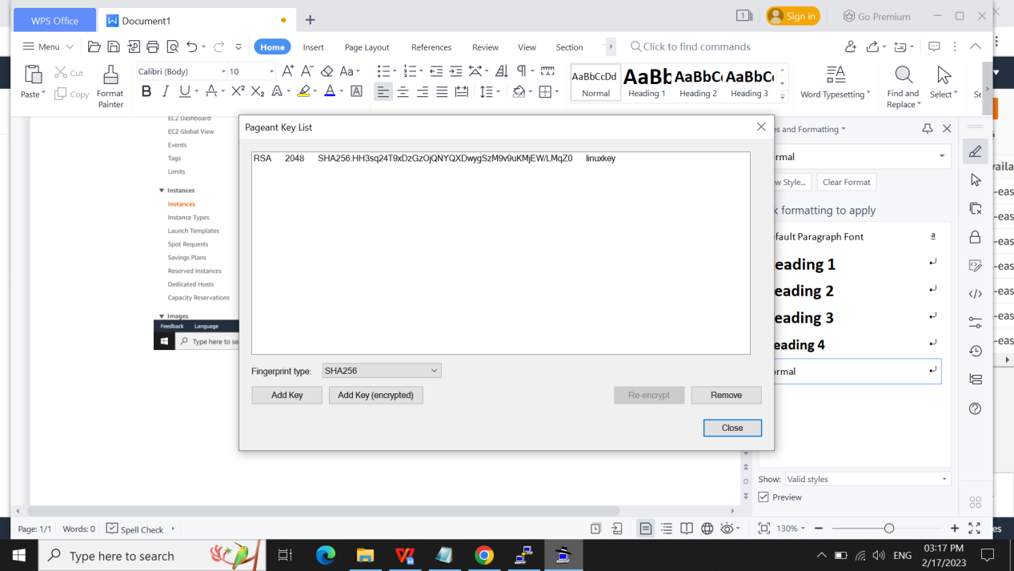

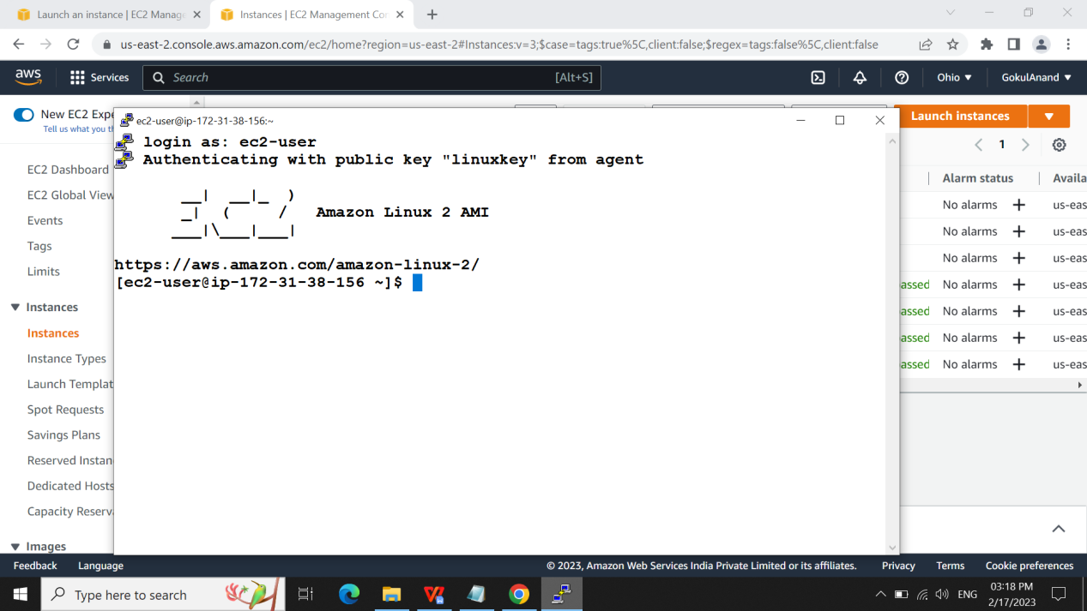

VI SLAVES.TXT:

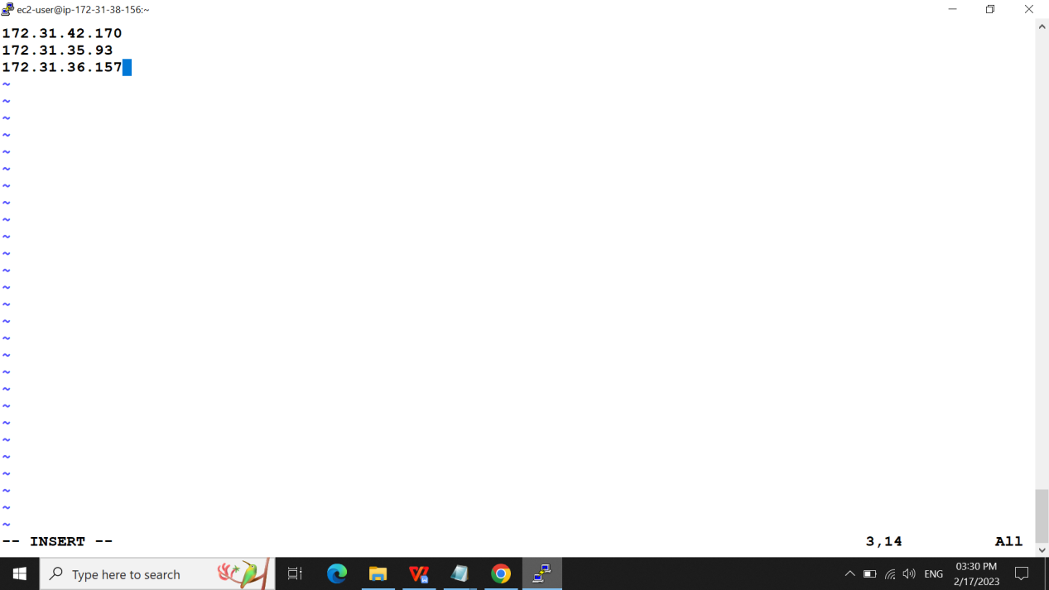

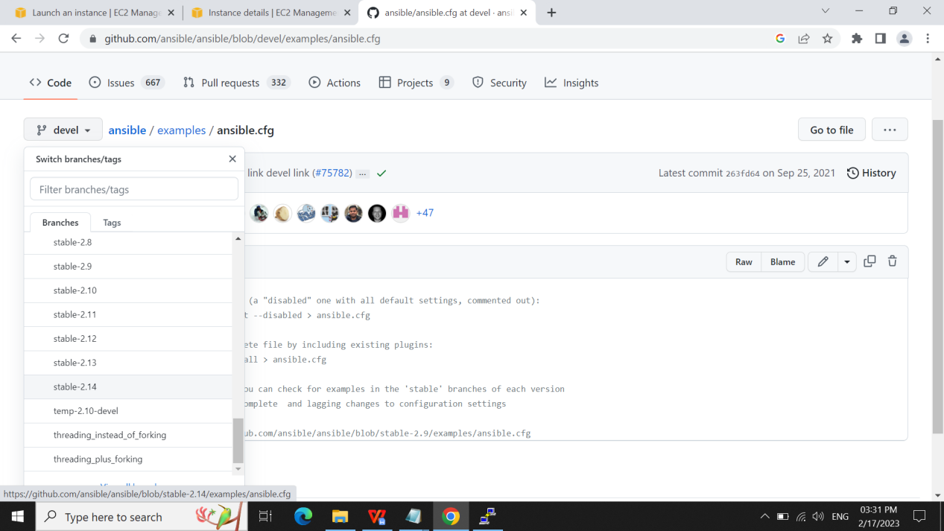

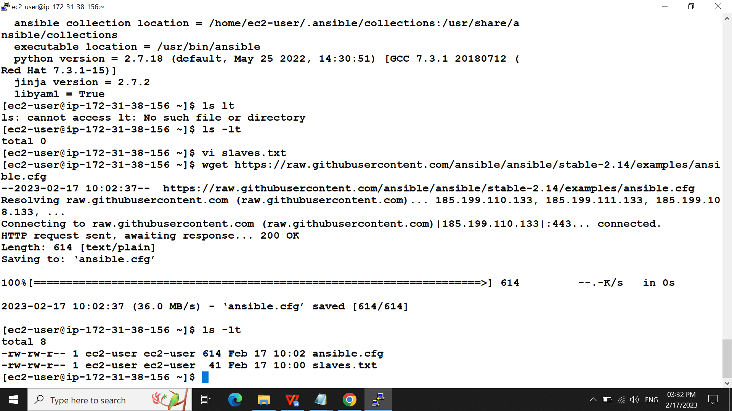

CHECKING WHEATHER SLAVES IS PINGING R NOT:

Ansible all -i slaves.txt -m ping

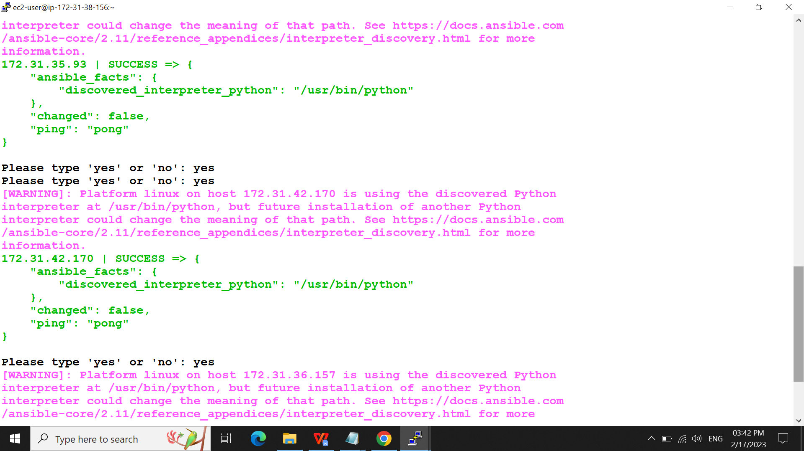

Checking uname and uptime:

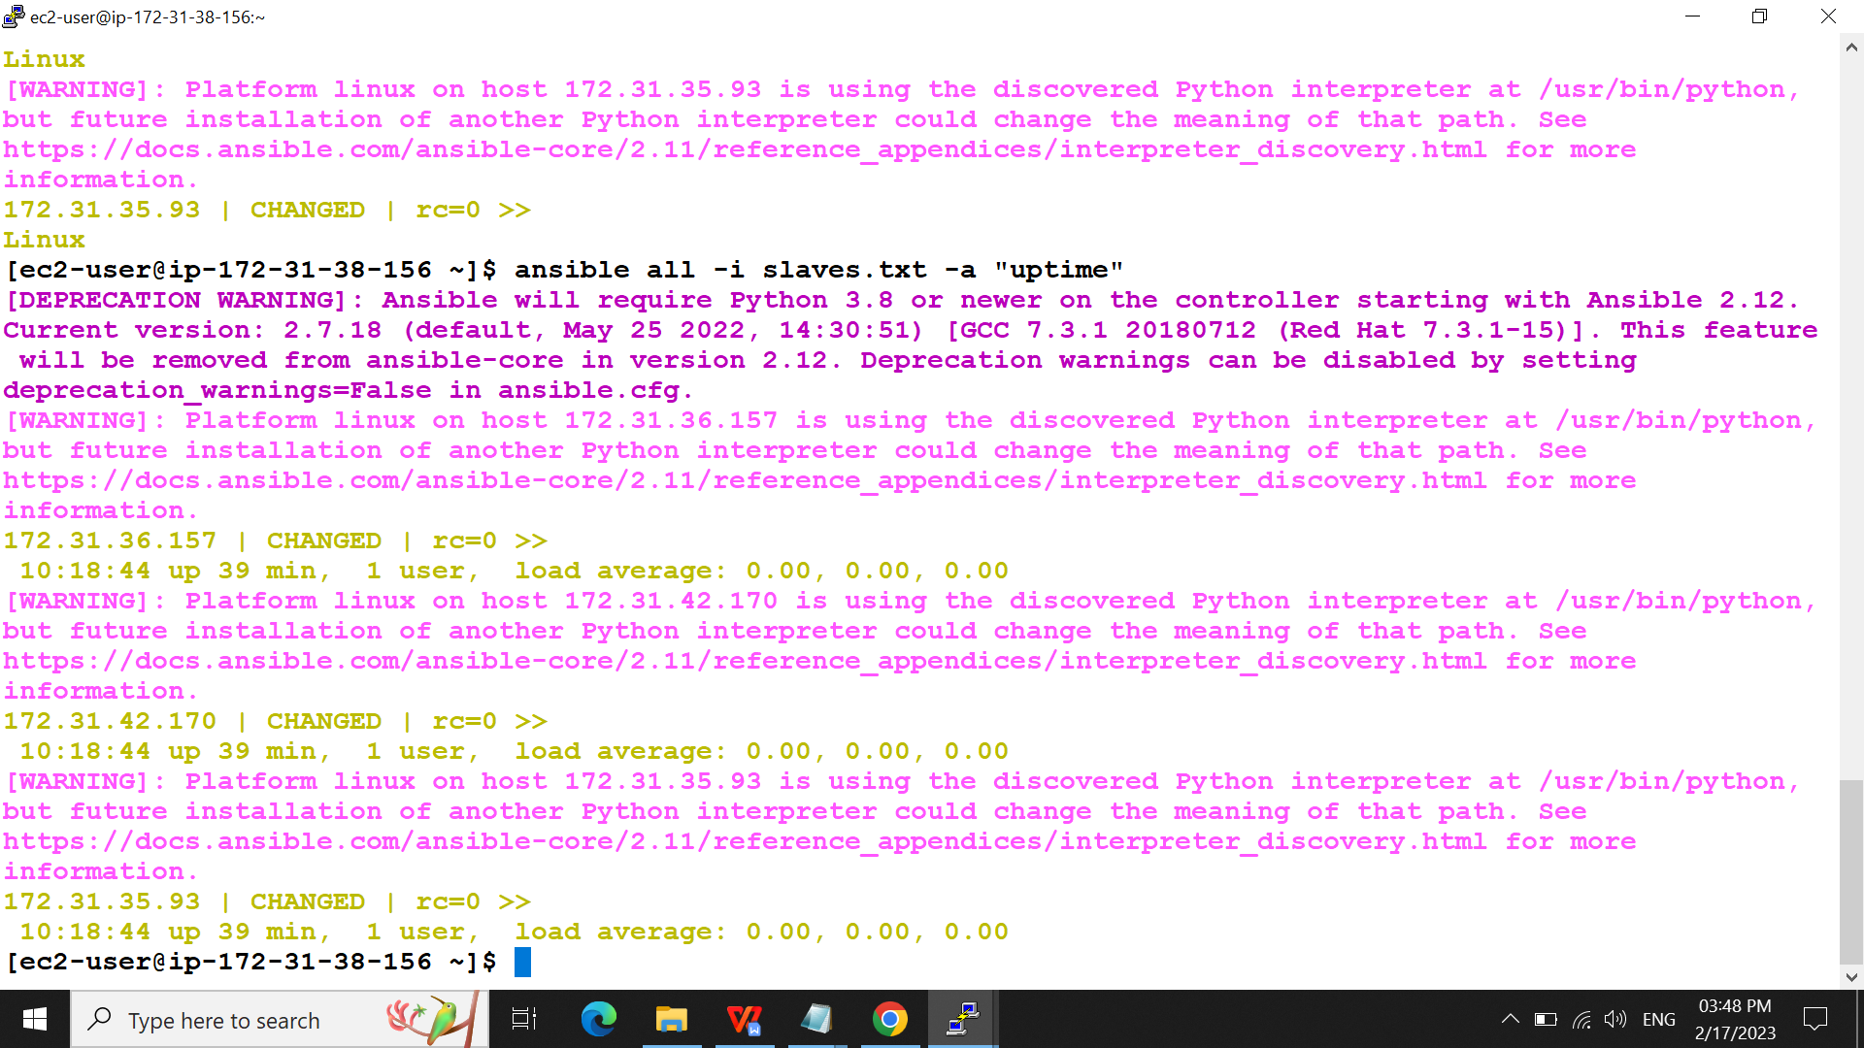

Grouping the ip:

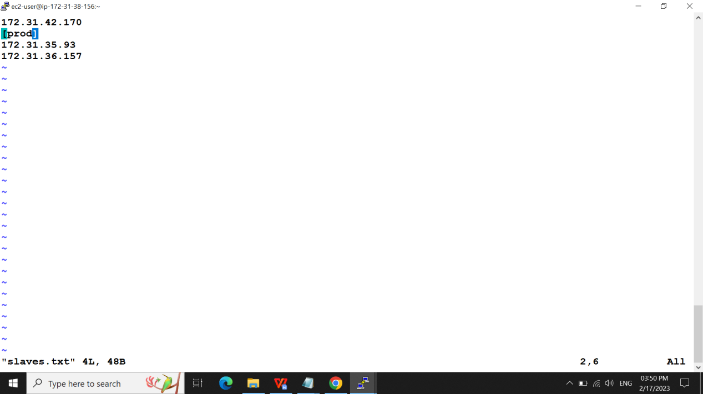

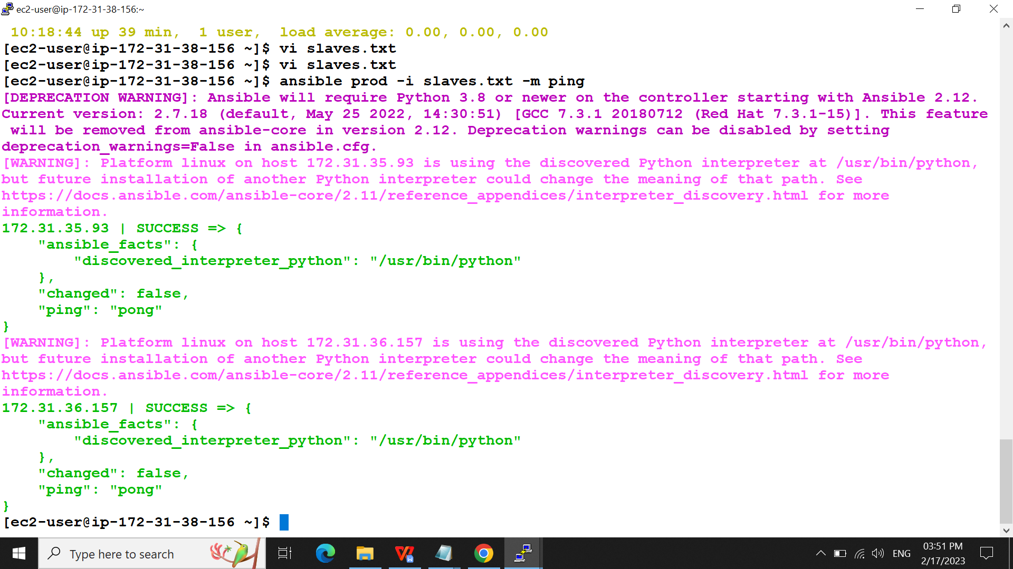

Installing apache only to the prod server:

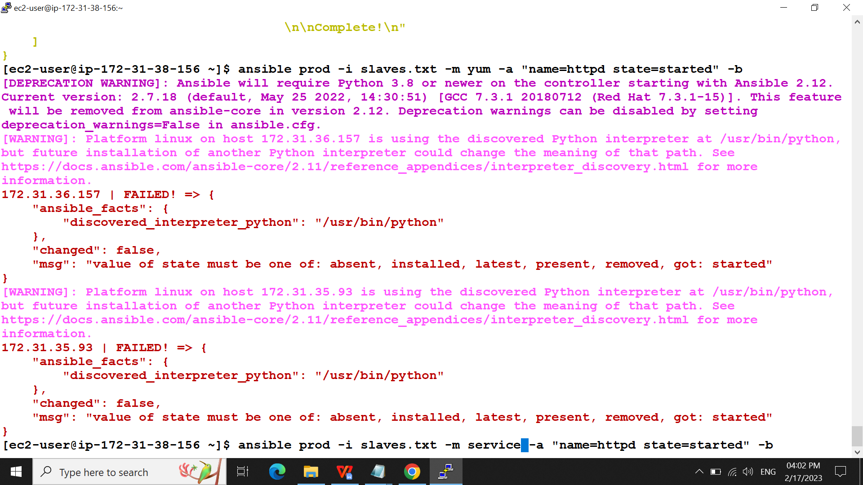

Soln is need to start the service: ansible prod -i slaves.txt -m service -a “name=httpd state” -b

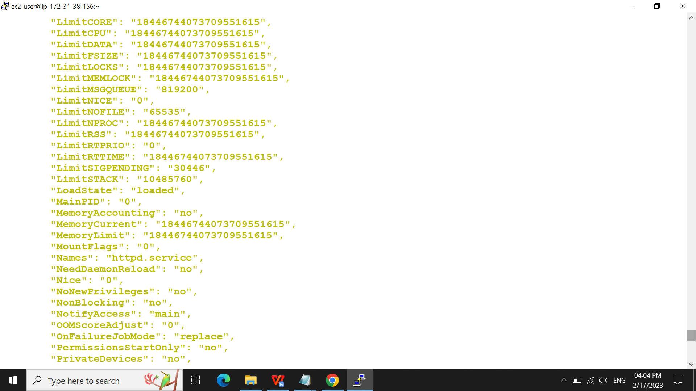

The output is

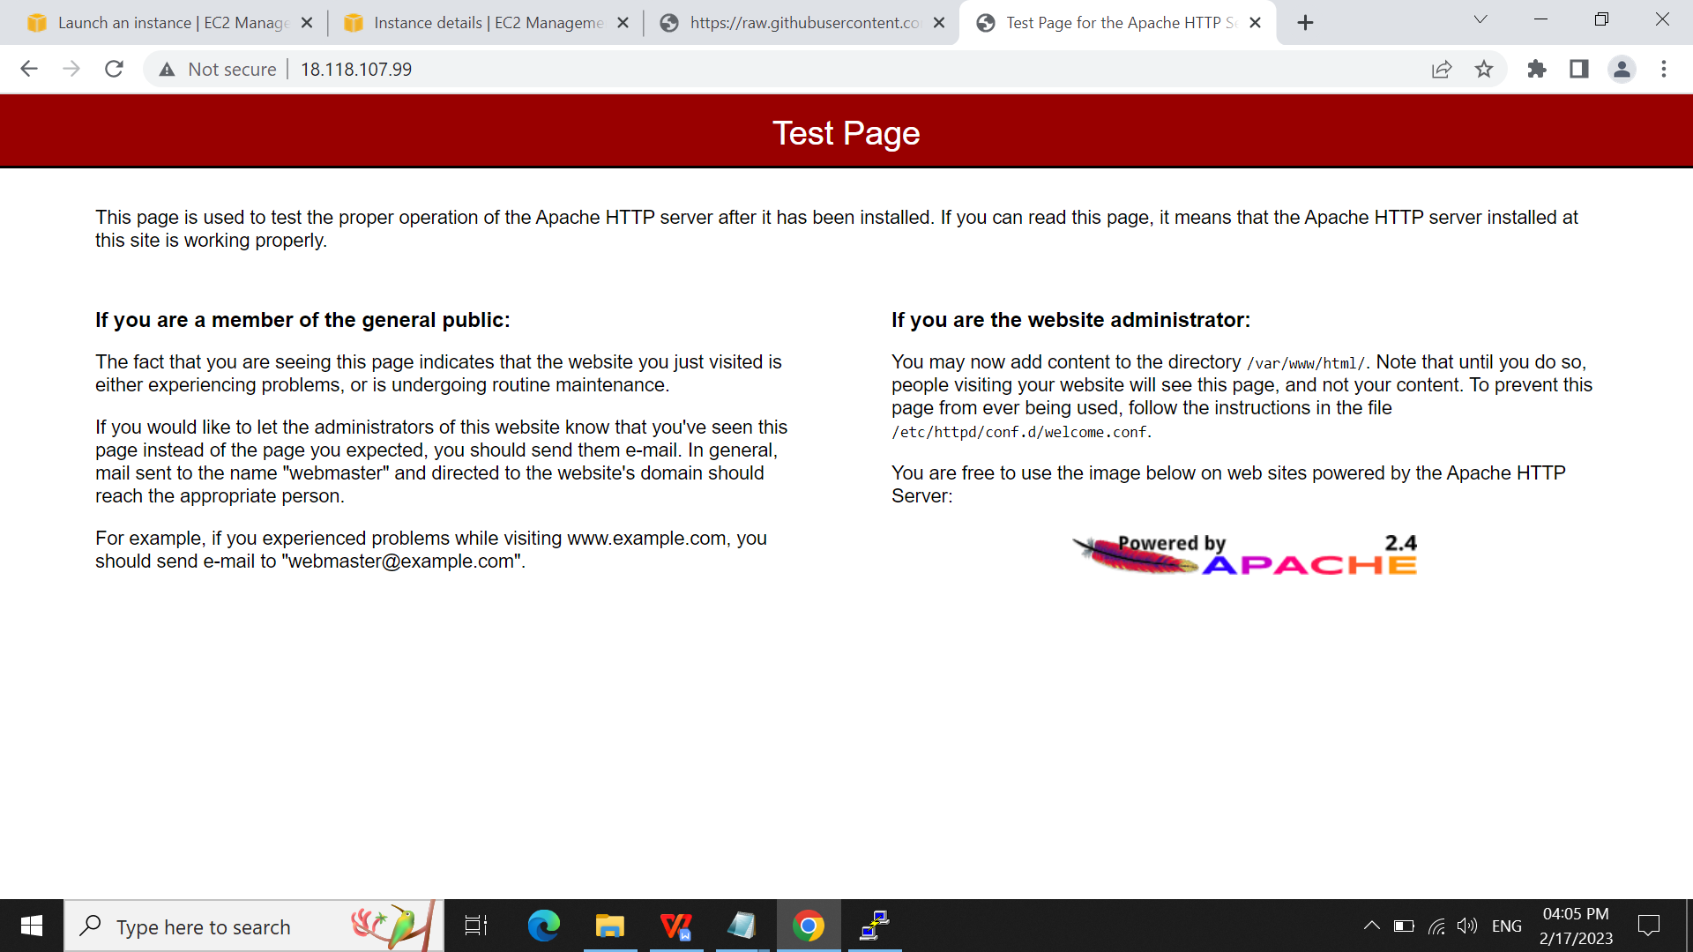

Installing git and observing the slave from the master server:

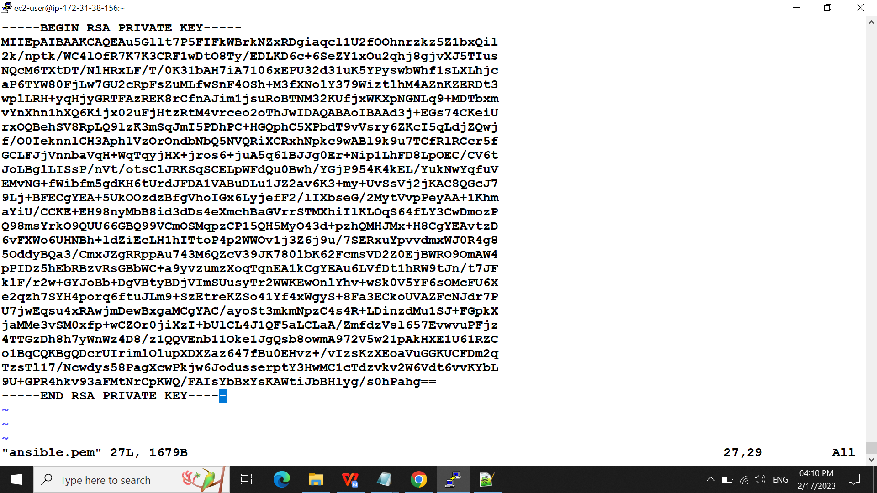

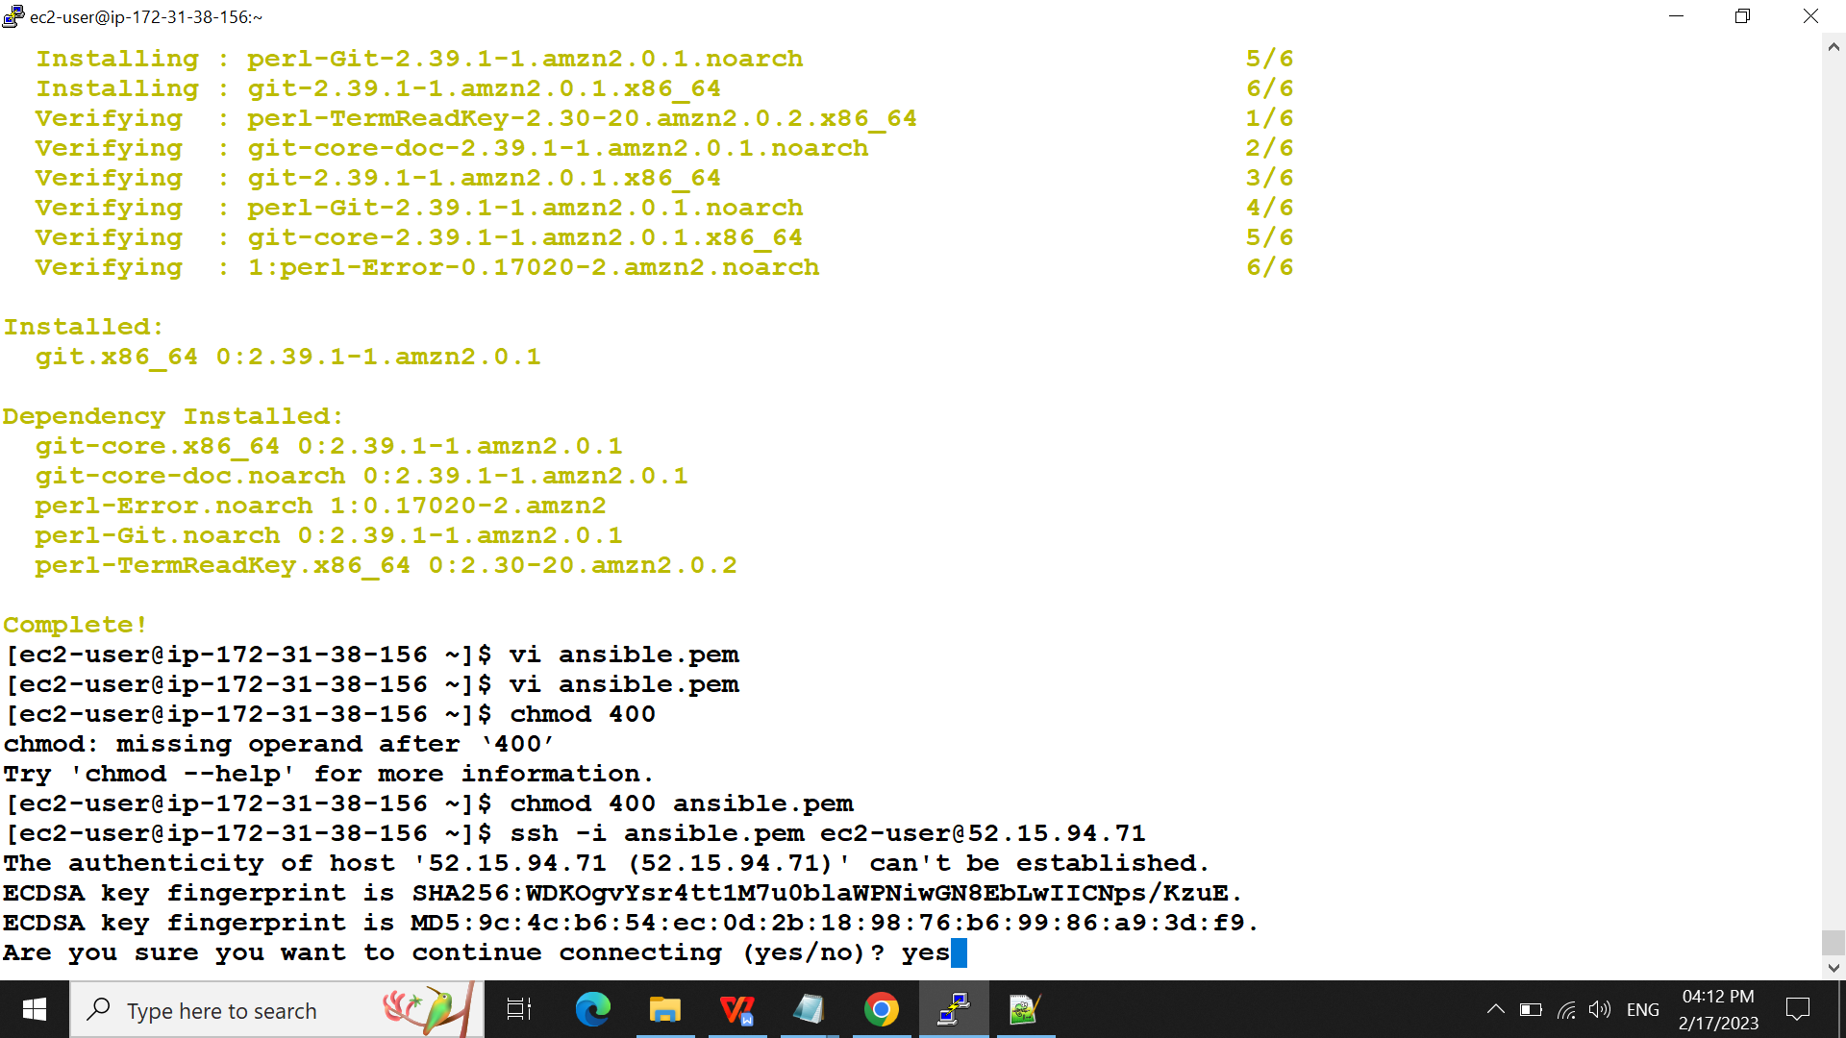

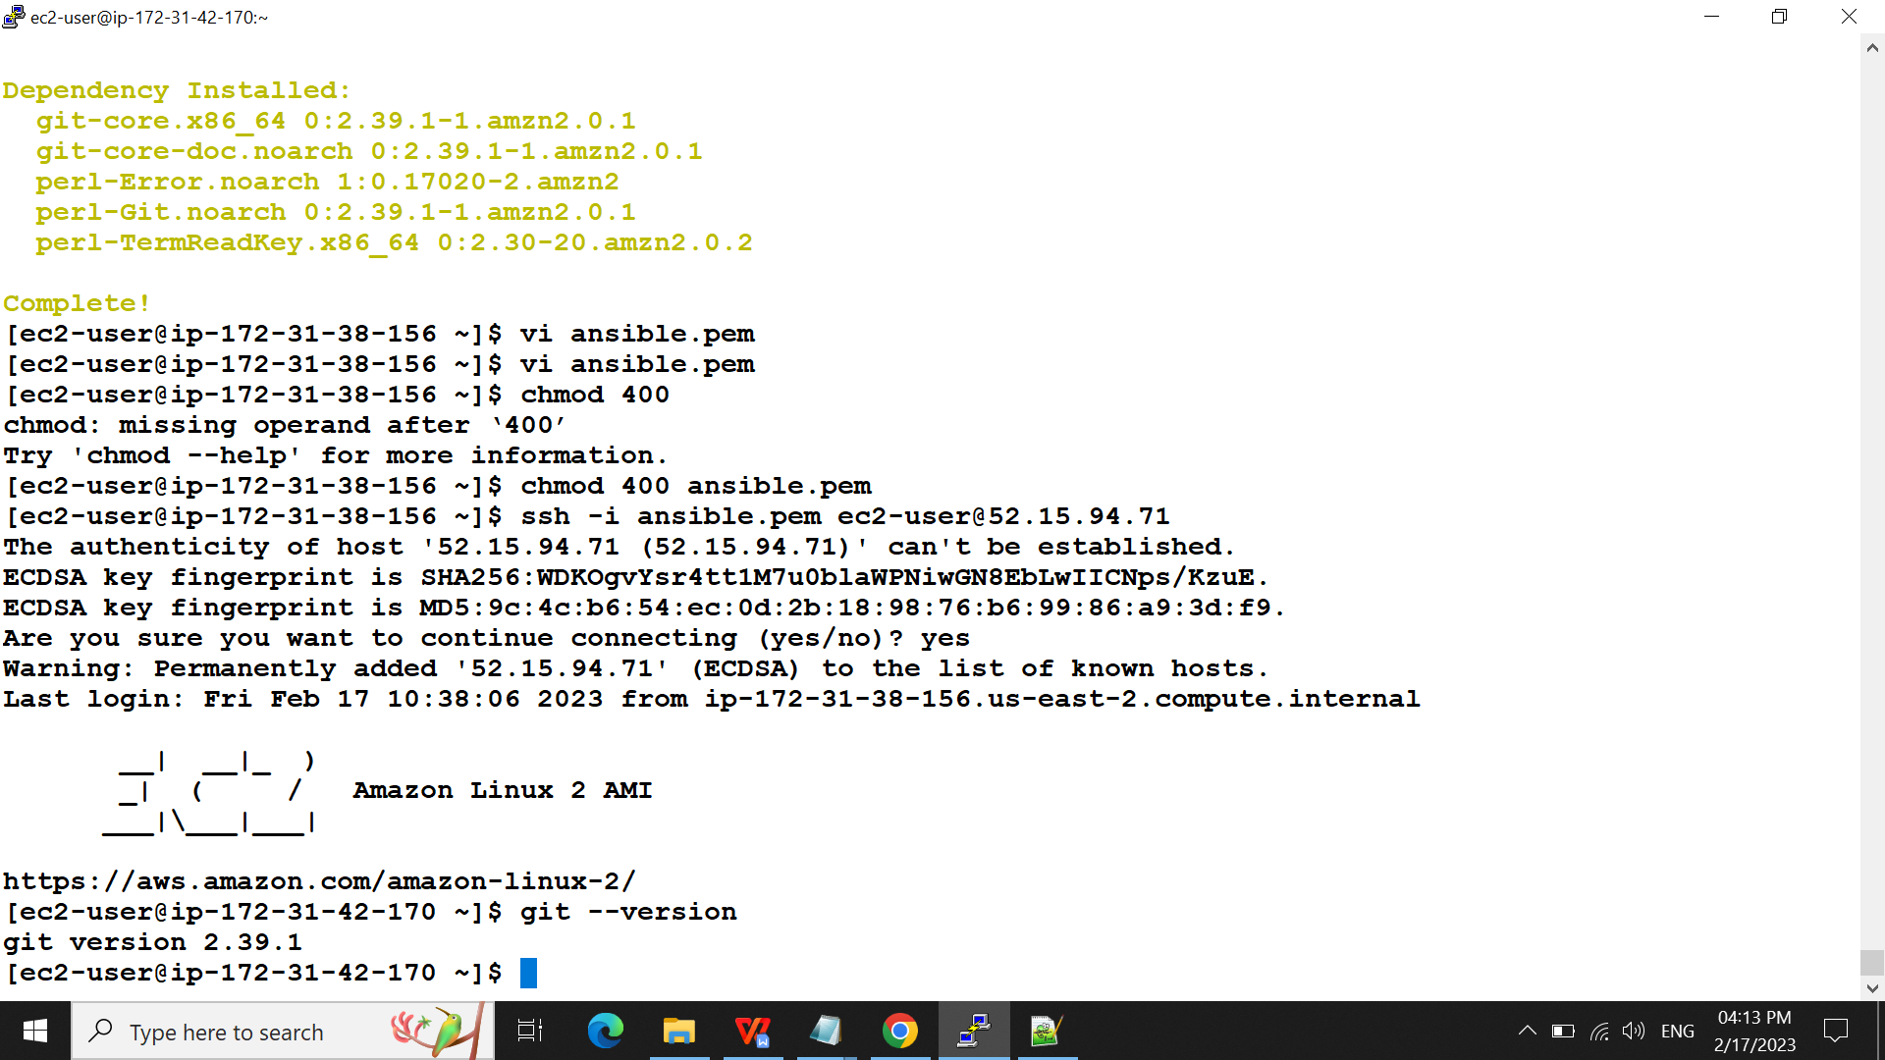

1 ansible all -i slaves.txt -m ping

2 vi ansible.cfg

3 ansible all -i slaves.txt -a "uname"

4 ansible all -i slaves.txt -a "uptime"

5 vi slaves.txt

6 ansible prod -i slaves.txt -m ping

7 ansible prod -i slaves.txt "name=httpd state=started" -b

8 ansible prod -i slaves.txt -a yum "name=httpd state=started" -b

9 ansible prod -i slaves.txt -m yum -a "name=httpd state=started" -b

10 ansible prod -i slaves.txt -m yum -a "name=httpd state=present" -b

11 ansible prod -i slaves.txt -m yum -a "name=httpd state=started" -b

12 ansible prod -i slaves.txt -m service -a "name=httpd state=started" -b

13 ansible all -i slaves.txt -a"yum install git -y"

14 ansible all -i slaves.txt -a "yum install git -y"

15 ansible all -i slaves.txt -a "yum install git -y" -b

16 vi ansible.pem

17 chmod 400

18 chmod 400 ansible.pem

19 ssh -i ansible.pem ec2-user@52.15.94.71

20 history

PART-B -playbook

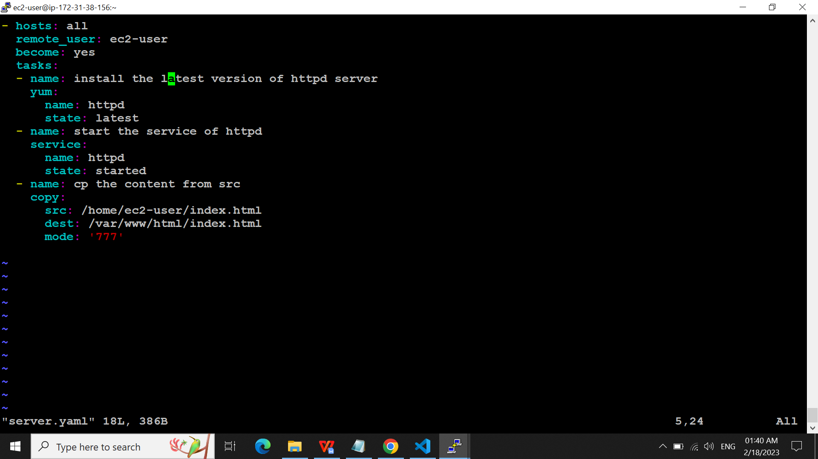

Ansible-playbook -I slaves.txt server.yml

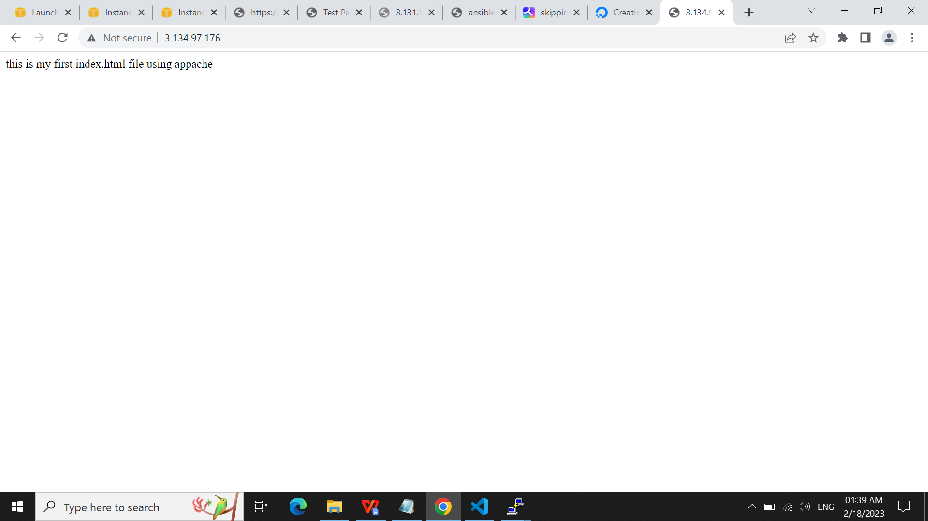

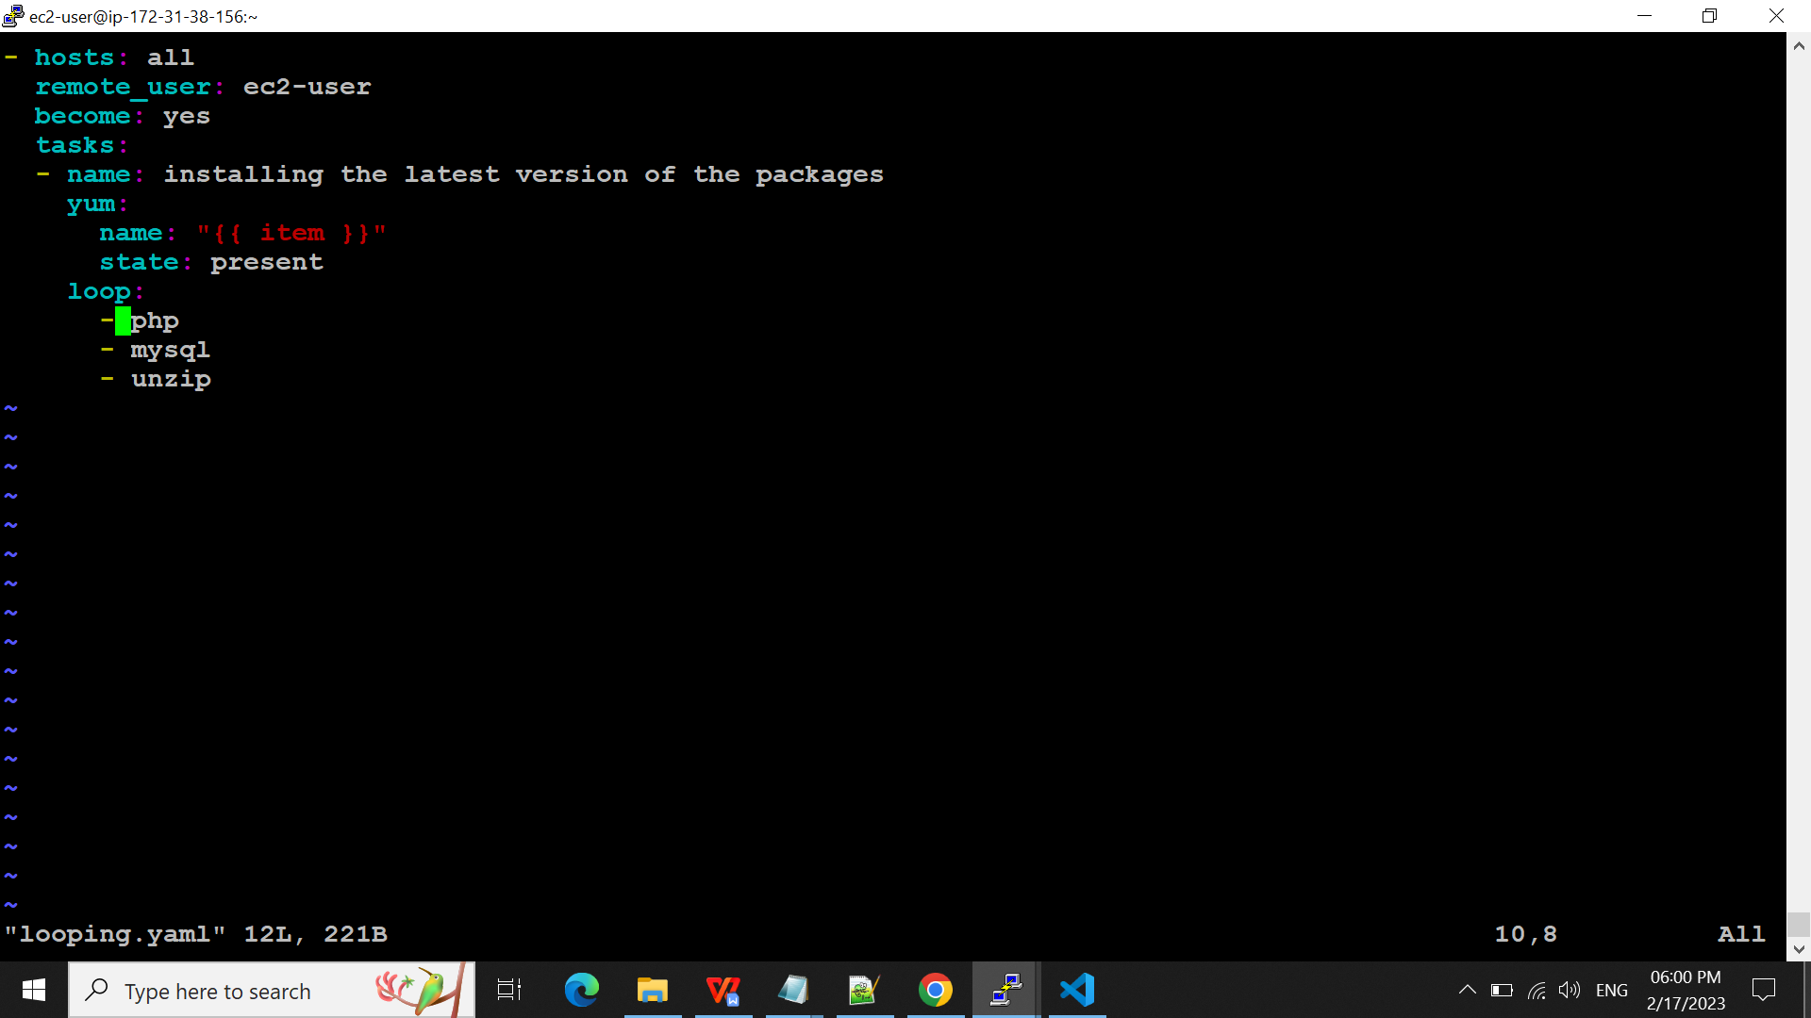

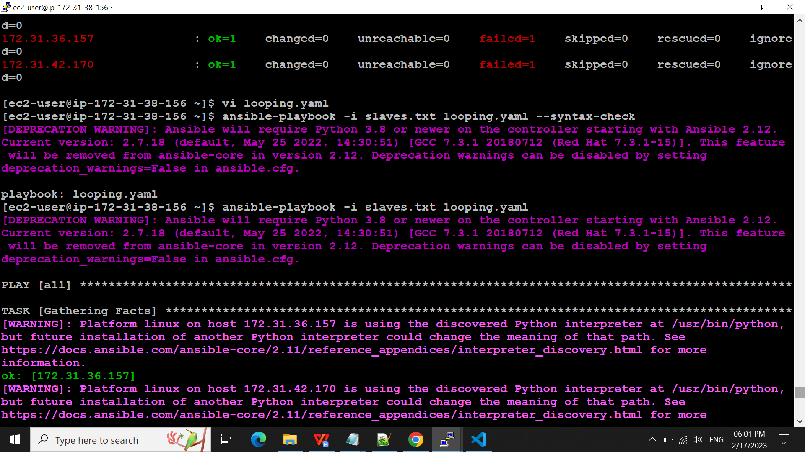

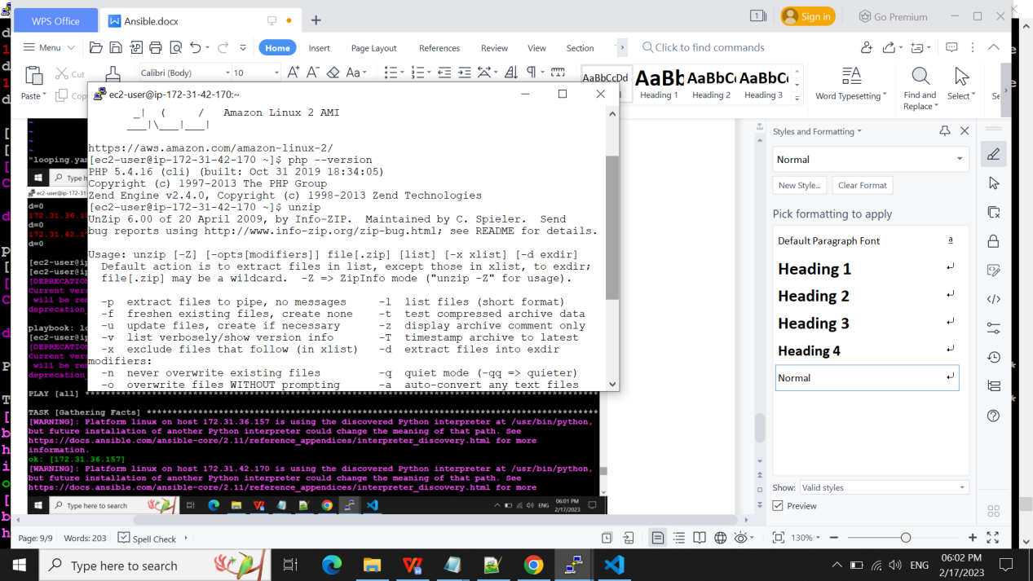

Vault:

Putting password and encrypting the yaml file. And if we cat that file it will be in decrypt format.

Ansible-vault encrypt looping.yaml

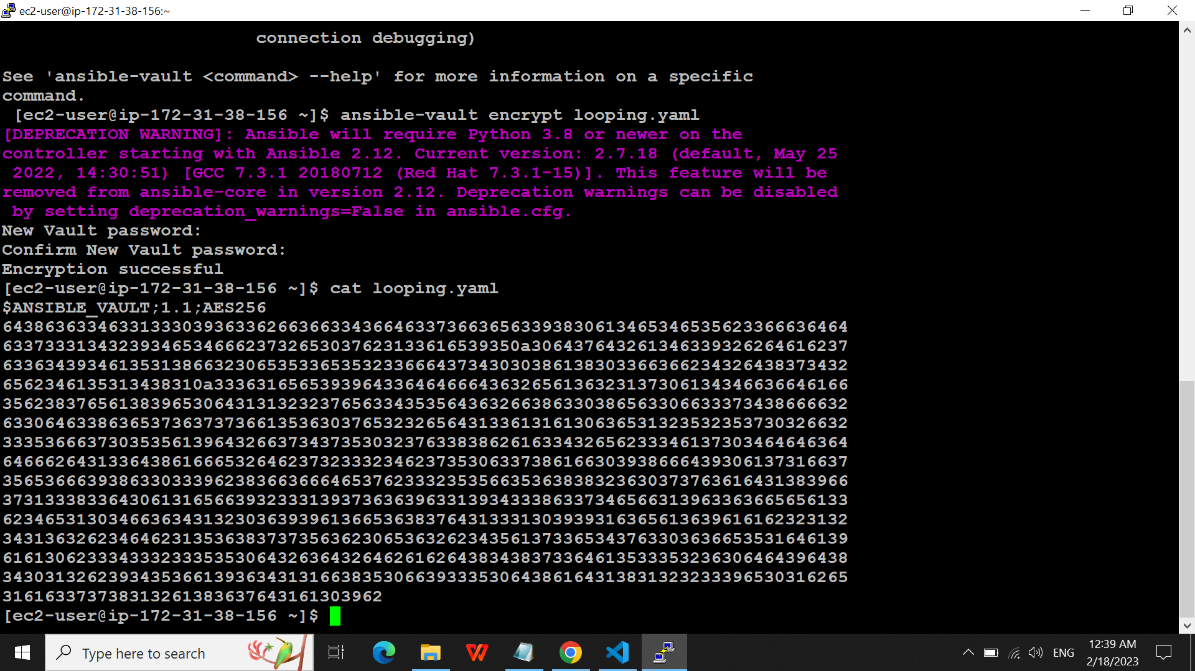

ansible-vault encrpyt looping.yaml

82 ansible-vault encrypt looping.yaml

83 cat looping.yaml

84 ansible-vault view looping.yaml

85 cat looping.yaml

86 ansible-vault edit looping.yaml

87 ansible-vault decrypt looping.yaml

88 cat looping.yaml

89 ansible-vault encrypt looping.yaml

90 ansible-vault rekey looping.yaml

91 ansible all -i slaves.txt

92 ansible all -i slaves.txt -m ping

93 ansible-playbook -i slaves.txt looping.yaml

94 ansible-playbook -i slaves.txt looping.yaml --ask-vault-pass

95 ansible-vault decrypt looping.yaml

96 cat looping.yaml